**Practical-13☺:**

The Smart Water System Company has developed an automatic tank refill system. This system starts refilling an empty tank (initially at 0 liters) until it reaches its maximum capacity of 100 liters. • The system refills the tank at a fixed rate of 10 liters per minute. • It displays the current water level after each refill. Write a program to simulate this process. Ensure the program stops automatically when the tank is full, displaying a message: "Tank is full." Expected sample outcome: Current water level: 10 liters Current water level: 20 liters ... Tank is full.

***Code:***

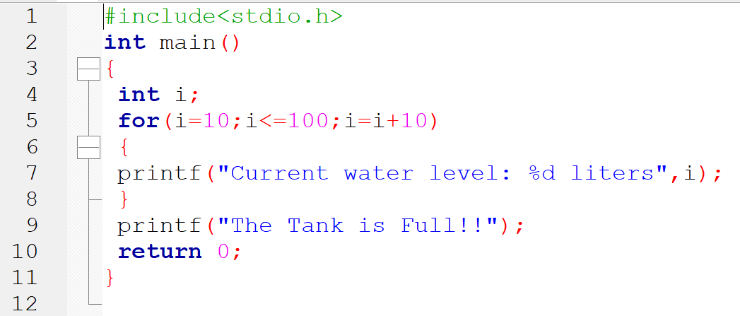

**Output:-**

